EXP NO 14 :Create a Snapshot of a VM and Test it by loading the Previous Version/Cloned
AIM:
To create a snapshot of a virtual machine (VM) using VMware Workstation, modify the VM, and verify that the previous state can be restored by loading the snapshot or using a cloned VM.
- RAM: 1 GB
- Hard Disk: 15 GB
- Processors: 2

PROCEDURE:
- Open VMware Workstation and select the virtual machine.
- Power on the virtual machine and ensure it is running normally.
- From the VM menu, select Snapshot → Take Snapshot.
- Enter a snapshot name and description, then click Take Snapshot.
- Make changes to the VM (e.g., create a file, install software, or modify settings).
- Shut down or restart the virtual machine.
- Go to VM → Snapshot → Snapshot Manager.
- Select the previously created snapshot and click Go To (Restore).
- Verify that the VM returns to its previous state before the changes were made.

1.SELECTING MEMORY DATA(GB):

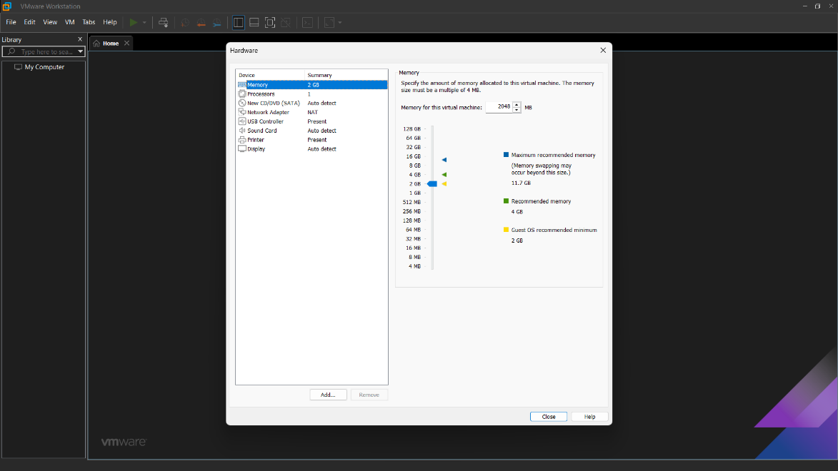

2.SELECTING NO. OF PROCESSORS:

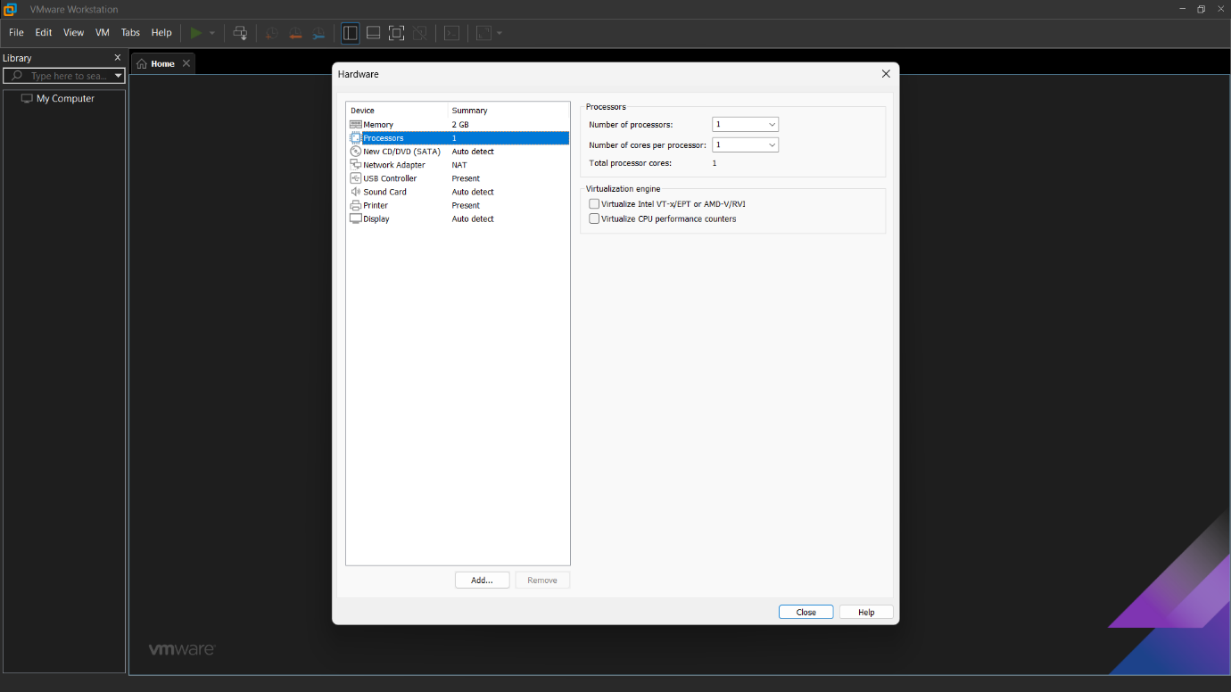

3.SETTING OF HARD DISK DATA(GB):

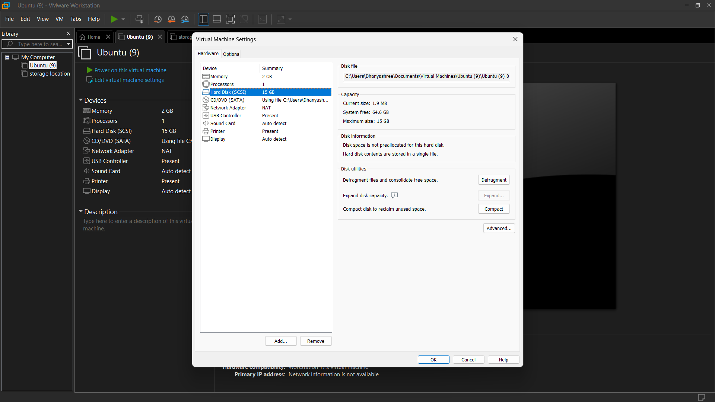

3. UPLOADING THE UBUNTU:
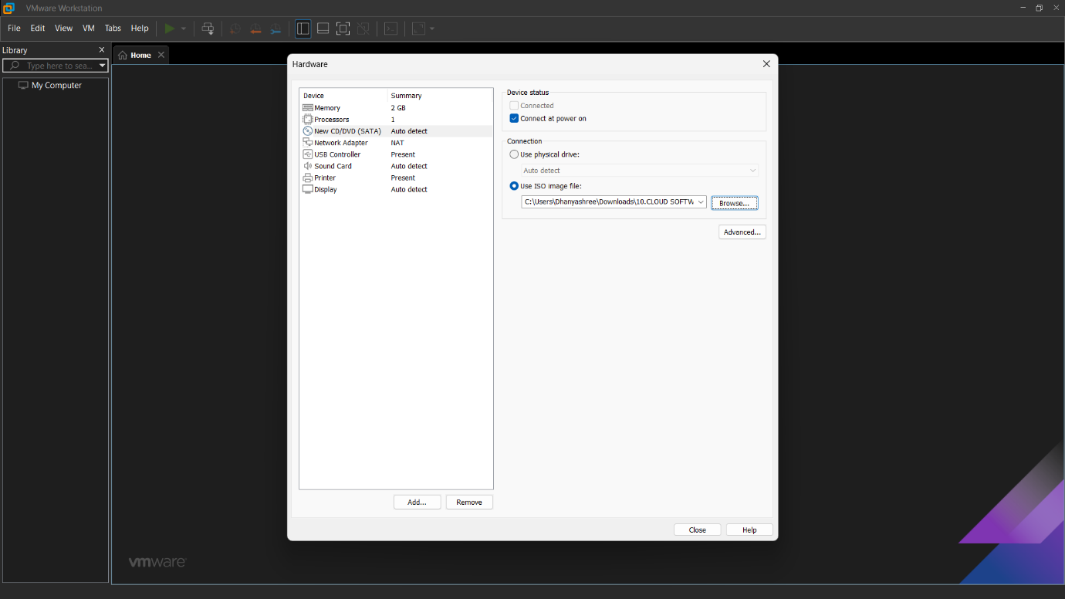

ADDING THE SNAPSOT:
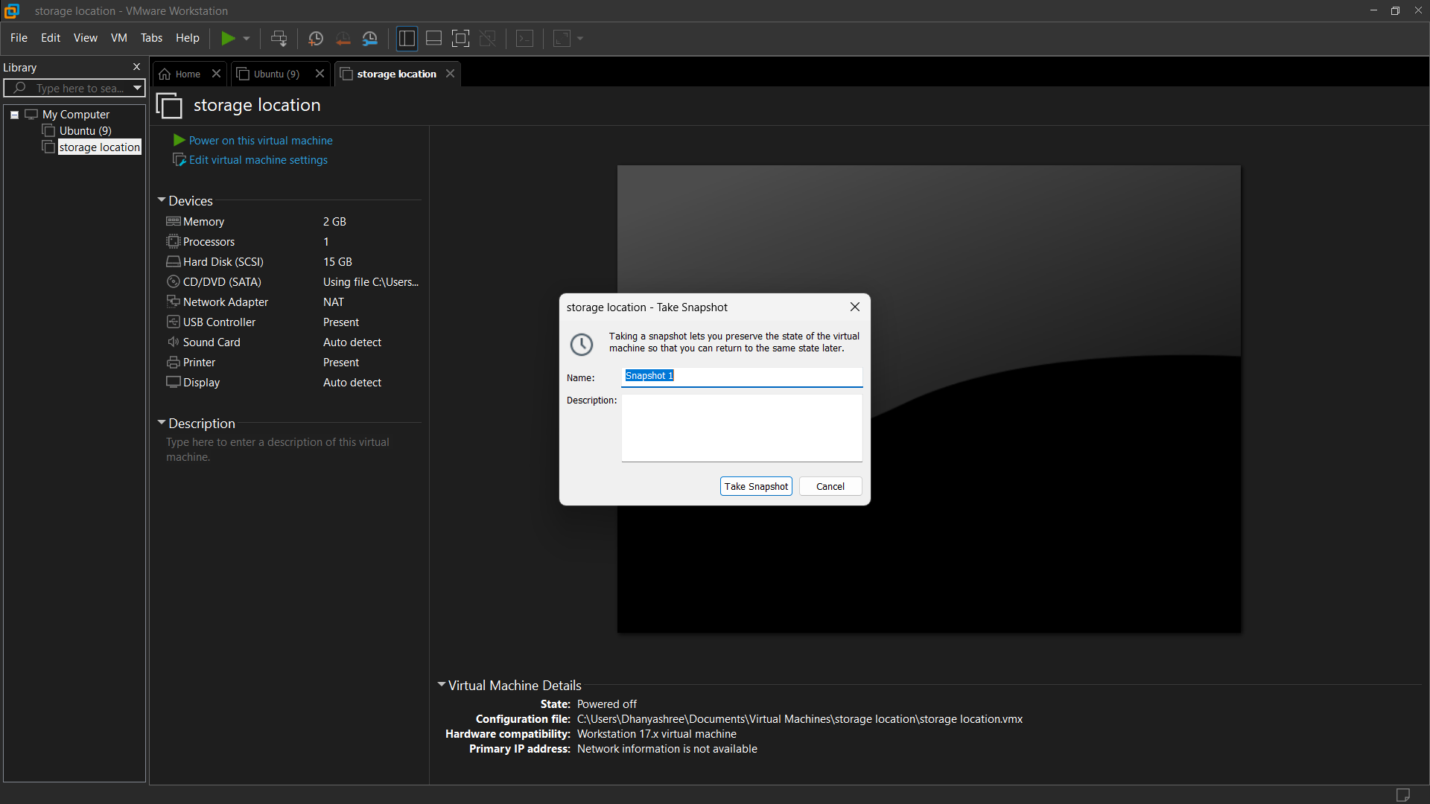
OUTPUT:
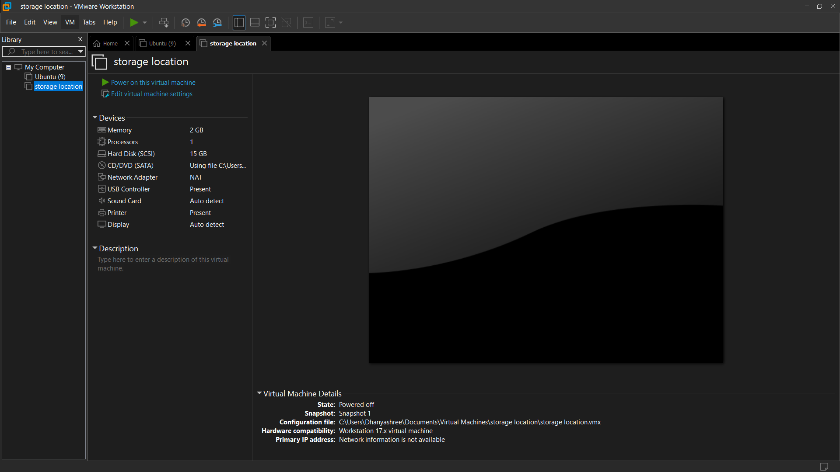
RESULT:
A virtual machine snapshot was successfully created and restored using VMware Workstation. The VM returned to its previous saved state after loading the snapshot. A cloned VM (if created) also functioned successfully, confirming that snapshots and cloning can be used for backup, recovery, and testing purposes.

